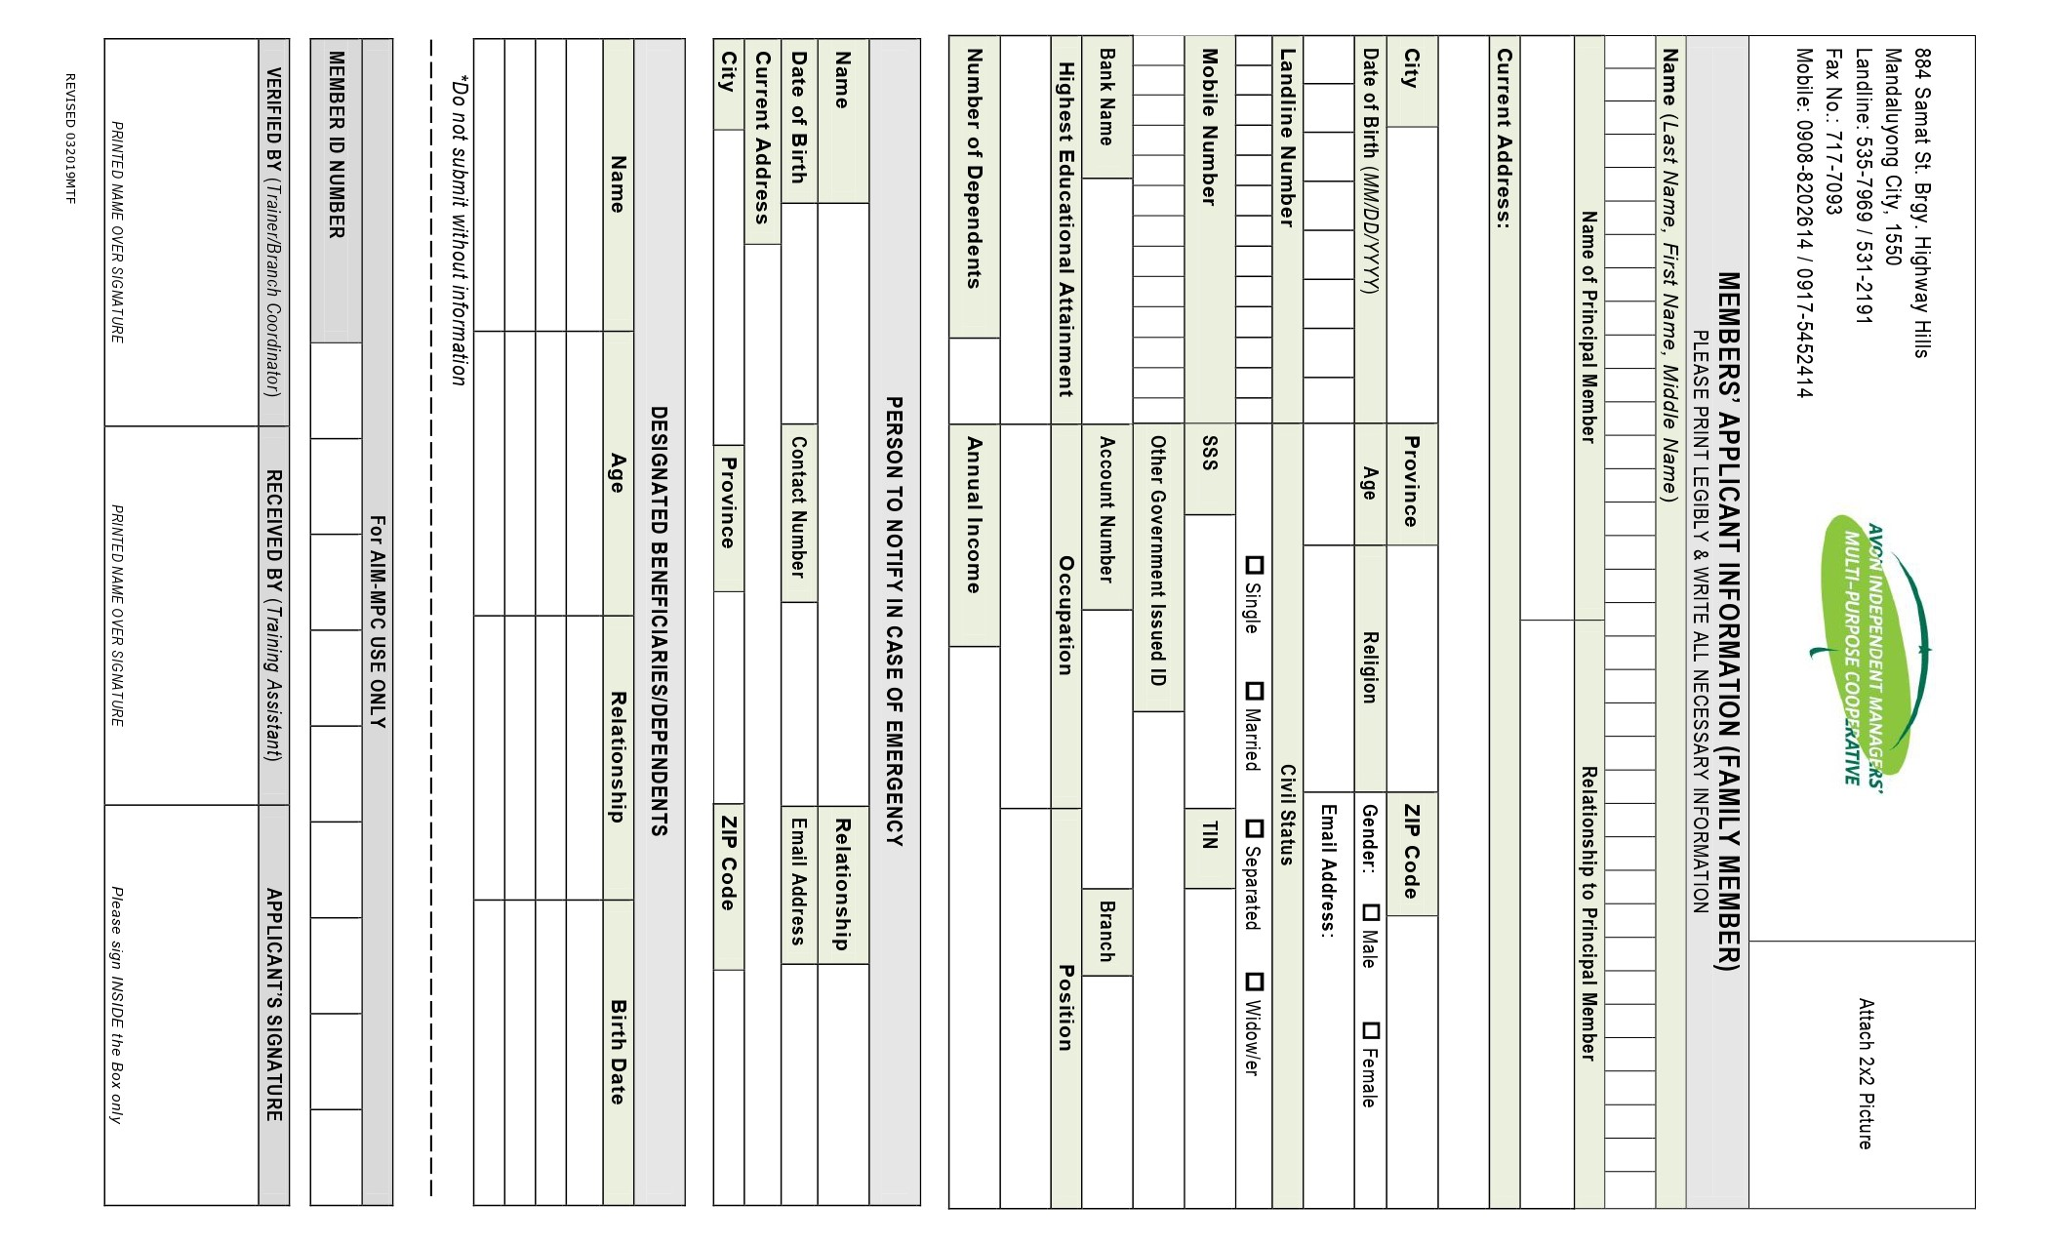
AVON Branch:
(ASSOCIATE MEMBER)

